CYBERQUOTE PTE LTD

Sales Performance Management
Phase III

Program Design Specification
- Assignment

For: | CYBERQUOTE PTE LTD | Project Ref: | POEMSAdmin00116
Author: | Thiri Lwin | Doc Ref: | SpmPhaseIII-TS-PS-Assignment-1.0
Proj Mgr: | Ei Ei Thu | Version:
Date: | 18/10/2011 | Classification:
To : |  | Cc:

Document Revision History

Document Title :

Version | Revised by | Effective Date | Summary of Change | Reason for change
1.0 | Thiri Lwin | 19/10/2011 | New Document | 1.0

Table of Contents

1 Program Definition 3
1.1 System Name 3
1.2 Program Description 3
1.3 Programming Language/Version 3
1.4 Drivers Required/Version 3
2 Structure Design 3
2.1 Block Chart or Flow Chart on top level structure of the program 3
2.1.1 Presentation Layer 4
2.1.2 Web Service Layer 6
2.2 Description of each module 9
2.2.1 Presentation Layer 9
2.2.2 WebService Layer 12
2.3 Description of Stored Procedures used 14
3 Input/Output files used 14
3.1 Input/Output file format design (with Samples attached) 14
3.2 Database connections used 14
4 Error Message/Warning Message List 14
5 Program List 15
6 Acceptance Form 16

Program Definition

System Name
Sales Performance Management (hereinafter referred as SPM) system Phase III

Program Description
This is the program design specification of “Assignment” function which is defined under “Assignment” in the design specification.

Programming Language/Version
This program will be developed in C# using Visual Studio 2008 for running under ASP.net 2.0.

Drivers Required/Version
The ASP.NET AJAX 1.0 is required to support Ajax in ASP.NET environment.

Structure Design

Block Chart or Flow Chart on top level structure of the program

Presentation Layer
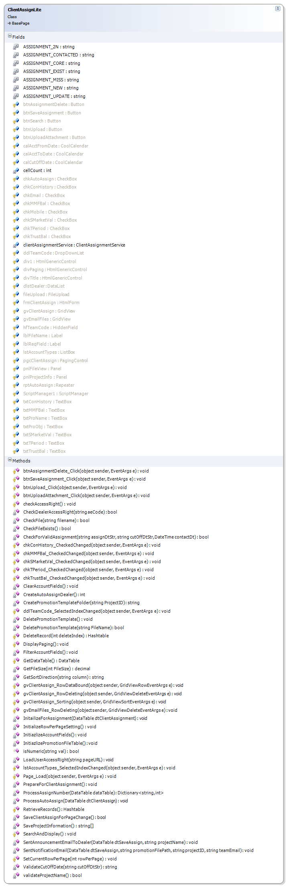
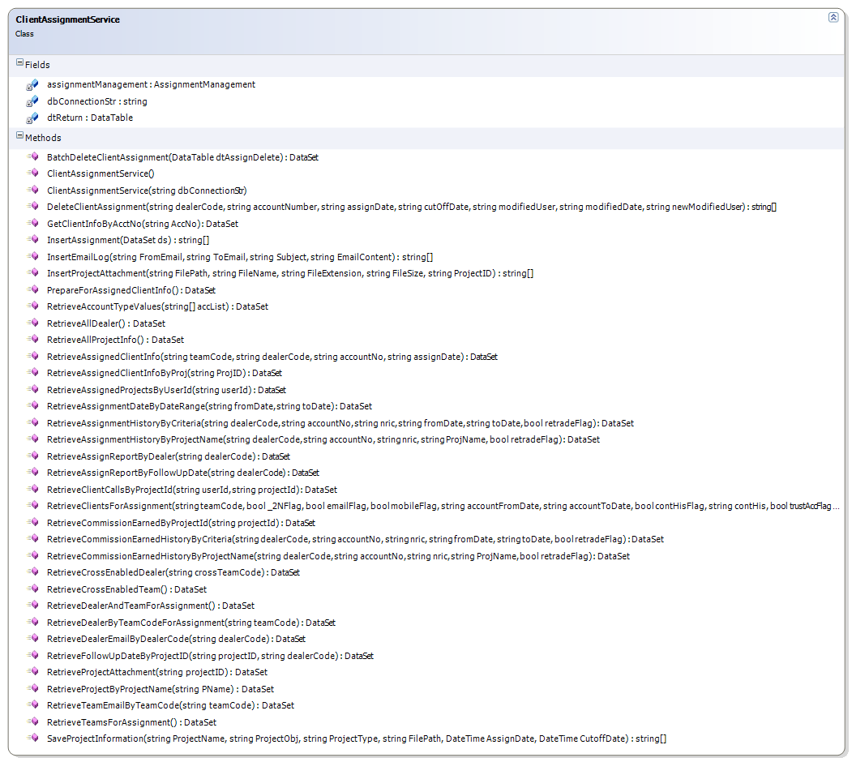

Web Service Layer

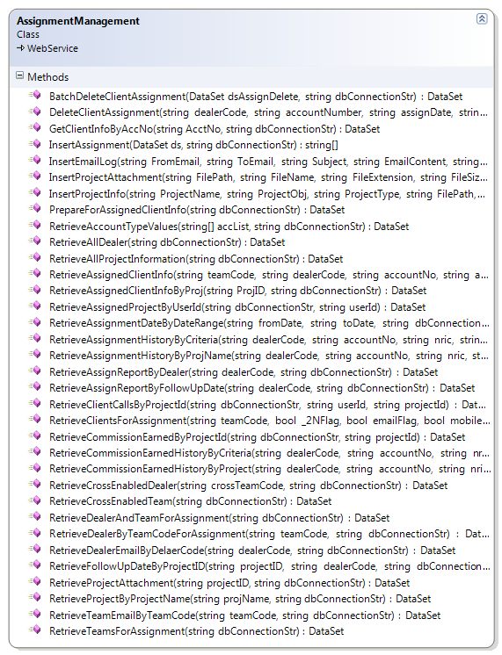
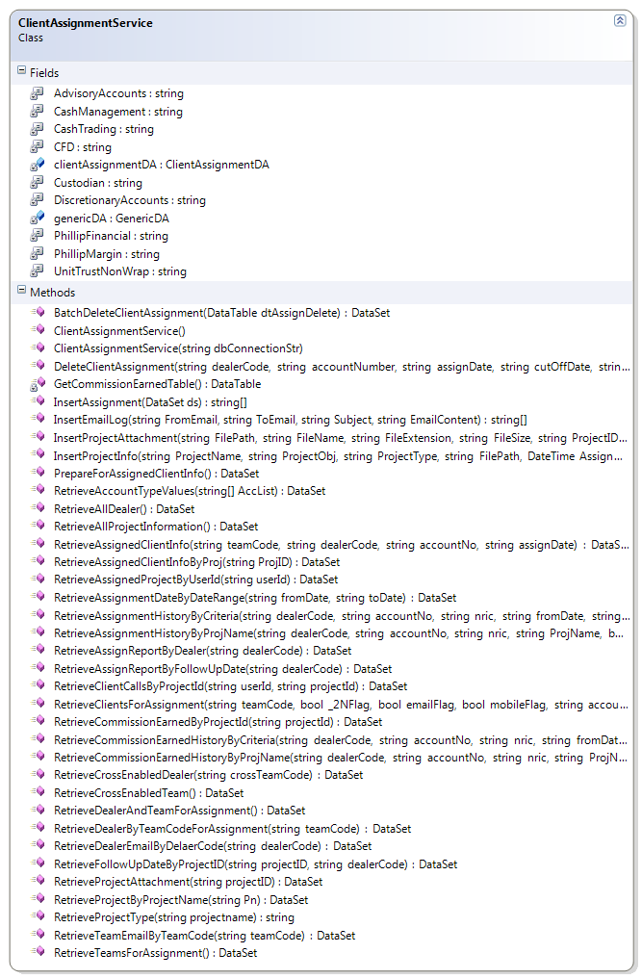
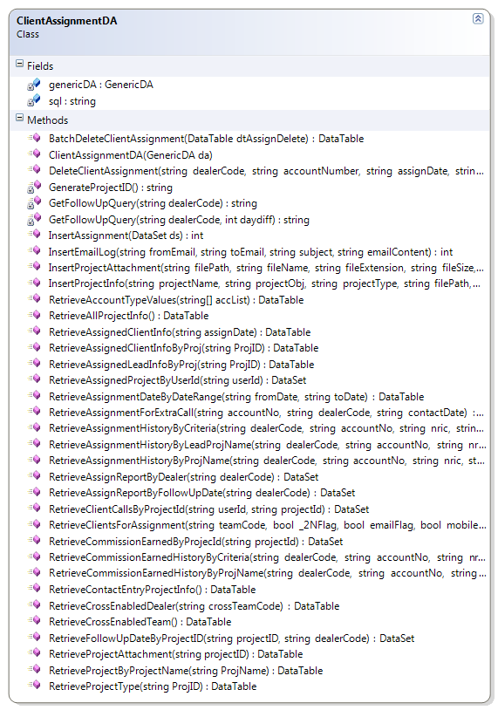

Description of each module

Presentation Layer

ClientAssignLite.aspx.cs
Member | Description
Fields
clientAssignmentService | Control for accessing web service layer
ASSIGNEMENT_NEW | To mark assignment record as new assignment.
ASSIGNEMENT_UPDATE | To mark assignment record as update assignment.
Methods
Page_Load | Retrieve and construct user dropdown list
PrepareForClientAssignment | Retrieve and construct teams dropdownlist.
RetrieveRecords | Retieve clients for assignments by calling clientAssignmentService.RetrieveClientsForAssignment() method;  Construct gridview to show client assignment records.
DeleteRecord | Delete valid assignment records.
SaveClientAssignForPageChange | Save the changes for current page before user move to another page.
InitailizeForAssignment | Fill cutoff date for new, already contacted and miss called assignments to do for next assignment.
CreateAutoAssignDealer | Create data table for selected auto assign dealers to show the auto assign result.
ProcessAutoAssign | Assign selected auto assign dealer to clients.
GetSortDirection | Retrieve stored sorting expression from ViewState and calculate new sorting expression and store it to ViewState.
CheckForValidAssignment | Helper method to check assignment record is valid within cutfoff date.
ValidateCutOffDate | Helper method to check user entered cutoff date for assignment is not blank and within valid period(i.e cutoff date must be one day after assign date).
InitializeRowPerPageSetting | Set default values for paging user control.
DisplayPaging | Use to display paging user control after assignment records are retrieved from database.
SetCurrentRowPerPage | Call from BasePage class to store current row per page in viewstate for paging control whenever user change the value.
GetDataTable | Call from BasePage class to get data to display whenever user change the page no (or) row per page.
ddlTeamCode_SelectedIndexChanged | Retrieve dealers of user selected team after user change to selection of the team dropdown list.
btnSaveAssignment_Click | Save the client assignment records to database. It will update the valid client assignment records if user made changes on it. And it will insert as new assignment record if the record is never assigned before (or) already contacted (or) miss called.
gvClientAssign_Sorting | Perform sorting on retrieved assignment records.
gvClientAssign_RowDataBound | Display the assignment records with following category:  - miss called assignments as red color  - valid assignment as yellow color  - core client as brown color  Fill the dealer into dropdown list and cutoff date into textbox to select for assignment.
gvClientAssign_RowDeleting | Delete the assignment record. Deletion can perform on valid assignment only.
btnAssignmentDelete_Click | Delete valid assignment records.
btnUpload_Click | Upload the promotion email templates
btnUploadAttachment_Click | Upload the attachment files
checkAccessRight | Check the user right for accessing web page
CheckDealerAccessRight | Check dealer right to access the web page  Based on the access right, dealer can select and assign to team
CheckFile | Helper method to check the files that it already exists or not for the assignment project
CheckFileExists | Helper method to check the promotion email template already exists or not
chkConHistory_CheckChanged | To enable and disable the textbox that key in the number of months based on check changed event
chkMMFBal_CheckedChanged | To enable and disable the textbox that key in to check the balance based on check changed event
chkSMarketVal_CheckedChanged | To enable and disable the textbox that key in to check the balance based on check changed event
chkTPeriod_CheckChanged | To enable and disable the textbox that key in the number of months based on check changed event
chkTrustBal_CheckedChanged | To enable and disable the textbox that key in to check the balance based on check changed event
ClearAccountFields | Set default values to Account Filter Fields
CreatePromotionTemplateFolder | To create promotion template folder under TemplateFiles folder based on project id
DeletePromotionTemplate | To delete the promotion template
FilterAccountFields | To retrieve account type ‘values based on the selected account types
GetFileSize | Helper method to calculated the files side that upload to system
gvEmailFiles_RowDeleting | Delete the Email files.
InitialzePromotionTable | Create data table for uploaded email files to show the select email files.
isNumerice | Helper method to check the numeric value
LoadUserAccessRight | Retrieve User Access Right
lstAccountTypes_SelectIndexChanged | Retrieve account values of user selected account types after user change to selection of the account type list.
ProcessAssignNumber | Retrieve and save the dealer information of user selected team after user change to selection of the team dropdown list.
SaveProjectInformation | Save the project information to database. Project information is used when assigned records save to Database.
SentAnnouncementEmailToDealer | Send announcement email to dealer from related team after saving assignment successfully to clients. It will include the information of  - No of clients assigned to dealer  - Deadline for the assignment
SentNotificationEmail | Send promotion email to client from sale performance system after saving assignment successfully to clients with uploaded promotion email template and related attachment files.
validProjectName | Helper method to check user entered project name for assignment is not blank and cannot entered same project name

ClientAssignmentService.cs
Member | Description
Fields
dbConnectionStr | Database connection string
assignmentManagement | Reference of the assignment management web service
dtReturn | Return Datatable
Methods
ClientAssignmentService | Constructor: to create assignment management web service instance
ClientAssignmentService (string cnStr) | Constructor: get database connection from caller after ClientAssignmentService () constructor
RetrieveClientsForAssignment | Retrieve client assignment records with the following condition:  - clients record which are never assigned  - client assignment records which are not  contacted yet but valid within cutoff date  - client assignment records which are already  contacted within valid cutoff date  - client assignment records which are missed to  call within cutoff date.
DeleteClientAssignment | Delete client assignment record which is valid within cutoff date.
InsertAssignment | This method save the client assignment record as the following:  - Insert the client assignment record if the  record is never assigned before  (or) already contacted (or) miss called.  - Update the client assignment record if the  record is not contacted yet and valid within  cutoff date.
BatchDeleteClientAssignment | Delete client assignment record which is valid within cutoff date.
InsertEmailLog | This method save the email record after sending the email with the following:  - FromEmail  - ToEmail  - Subject  - EmailContent
InsertProjectAttachment | This method save the email attachment files as the following:  - Insert the email attachment files if the  Project information is already saved in Database
RetrieveProjectAttachment | Retrieve email attachment files according to the project id.
RetrieveAccountTypeValues | Retrieve account type values based on the selected account types.
RetrieveAllProjectInfo | Retrieve related assignment project information
RetrieveDealerEmailByDealerCode | Retrieve dealer information based on the dealer code
RetrieveTeamEmailyByTeamCode | Retrieve team information based on the team code
SaveProjectInformation | This method save the project information as the following:  - Insert the project information if there have any record to assign.

WebService Layer

AssignmentManagementService.asmx.cs
Member | Description
Methods
RetrieveClientsForAssignment | Retrieve client assignment records with the following condition:  - clients record which are never assigned  - client assignment records which are not  contacted yet but valid within cutoff date  - client assignment records which are already  contacted within valid cutoff date  - client assignment records which are missed to  call within cutoff date.
DeleteClientAssignment | Delete client assignment record which is valid within cutoff date.
InsertAssignment | This method save the client assignment record as the following:  - Insert the client assignment record if the  record is never assigned before  (or) already contacted (or) miss called.  - Update the client assignment record if the  record is not contacted yet and valid within  cutoff date.
BatchDeleteClientAssignment | Delete client assignment record which is valid within cutoff date.
InsertEmailLog | This method save the email record after sending the email with the following:  - FromEmail  - ToEmail  - Subject  - EmailContent
InsertProjectAttachment | This method save the email attachment files as the following:  - Insert the email attachment files if the  Project information is already saved in Database
RetrieveProjectAttachment | Retrieve email attachment files according to the project id.
RetrieveAccountTypeValues | Retrieve account type values based on the selected account types.
RetrieveAllProjectInformation | Retrieve related assignment project information
RetrieveDealerEmailByDealerCode | Retrieve dealer information based on the dealer code
RetrieveTeamEmailyByTeamCode | Retrieve team information based on the team code
InsertProjectInfo | This method save the project information as the following:  - Insert the project information if there have any record to assign.

ClientAssignmentService.cs
Member | Description
Fields
clientAssignmentDA | Data access layer for client assignment services
dtReturn | Return data table
GenericDA | Generic data access layer
Methods
ClientAssignmentService | Constructor: to create generic data access and client assignment data access instance
ClientAssignmentService (string cnStr) | Constructor: get database connection from caller after ClientAssignmentService () constructor
RetrieveClientsForAssignment | Retrieve client assignment records with the following condition:  - clients record which are never assigned  - client assignment records which are not  contacted yet but valid within cutoff date  - client assignment records which are already  contacted within valid cutoff date  - client assignment records which are missed to  call within cutoff date.
DeleteClientAssignment | Delete client assignment record which is valid within cutoff date.
InsertAssignment | This method save the client assignment record as the following:  - Insert the client assignment record if the  record is never assigned before  (or) already contacted (or) miss called.  - Update the client assignment record if the  record is not contacted yet and valid within  cutoff date.
BatchDeleteClientAssignment | Delete client assignment record which is valid within cutoff date.
InsertEmailLog | This method save the email record after sending the email with the following:  - FromEmail  - ToEmail  - Subject  - EmailContent
InsertProjectAttachment | This method save the email attachment files as the following:  - Insert the email attachment files if the  Project information is already saved in Database
RetrieveProjectAttachment | Retrieve email attachment files according to the project id.
RetrieveAccountTypeValues | Retrieve account type values based on the selected account types.
RetrieveAllProjectInformation | Retrieve related assignment project information
RetrieveDealerEmailByDealerCode | Retrieve dealer information based on the dealer code
RetrieveTeamEmailyByTeamCode | Retrieve team information based on the team code
InsertProjectInfo | This method save the project information as the following:  - Insert the project information if there have any record to assign.
InsertAssignment | This method save the client assignment record as the following:  - Insert the client assignment record if the  record is never assigned before  (or) already contacted (or) miss called.  - Update the client assignment record if the  record is not contacted yet and valid within  cutoff date.

ClientAssignmentDA.cs
Member | Description
Fields
GenericDA | Generic data access layer
sql | Sql statements
Methods
RetrieveClientsForAssignment | Retrieve client assignment records with the following condition:  - clients record which are never assigned  - client assignment records which are not  contacted yet but valid within cutoff date  - client assignment records which are already  contacted within valid cutoff date  - client assignment records which are missed to  call within cutoff date.
DeleteClientAssignment | Delete client assignment record which is valid within cutoff date.
InsertAssignment | This method save the client assignment record as the following:  - Insert the client assignment record if the  record is never assigned before  (or) already contacted (or) miss called.  - Update the client assignment record if the  record is not contacted yet and valid within  cutoff date.- Insert the client assignment record if the  record is never assigned before  (or) already contacted (or) miss called.  - Update the client assignment record if the  record is not contacted yet and valid within  cutoff date.
BatchDeleteClientAssignment | Delete client assignment record which is valid within cutoff date.
InsertEmailLog | This method save the email record after sending the email with the following:  - FromEmail  - ToEmail  - Subject  - EmailContent
InsertProjectAttachment | This method save the email attachment files as the following:  - Insert the email attachment files if the  Project information is already saved in Database
RetrieveProjectAttachment | Retrieve email attachment files according to the project id.
RetrieveAccountTypeValues | Retrieve account type values based on the selected account types.
RetrieveAllProjectInfo | Retrieve related assignment project information
RetrieveDealerEmailByDealerCode | Retrieve dealer information based on the dealer code from AEListDA.cs
RetrieveTeamEmailyByTeamCode | Retrieve team information based on the team code AEListDA.cs
InsertProjectInfo | This method save the project information as the following:  - Insert the project information if there have any record to assign.

Description of Stored Procedures used
None

Input/Output files used
None

Input/Output file format design (with Samples attached)
N/A

Database connections used
BasePage.dbConnectionStr

Error Message/Warning Message List
Message | Cause
“Please select team first before searching clients.” | User search clients without selecting the team.
No clients found! Please change your search criteria.! | No matched record is found for user entered search criteria.
“Please select dealers for Auto Assignment.” | User select auto assignment without selecting dealers.
Error in retrieving Assignments! Please try again. | When system failed to retrieve assignment records.
Problem in WebService Connection! | When system failed to call web service
You have not specified a value | User searches the clients without key in the account filtering value.
Please Enter Numeric value | User searches the clients with character instead of using numeric value in account filtering .
There is no assignment to save! | User does not assign record to save in the project.
Error in saving project information! | There is no complete information to save the project information.
Project Name Already Exists in System. | User enters the project name that already saves as project.

Program List
SPMWebApp\Services
ClientAssignmentService.cs

SPMWebApp\WebPages\AssignmentManagement
ClientAssignmentLite.aspx
ClientAssignmentLite.aspx.cs
ClientAssignmentLite.aspx.designer.cs

SPMWebServiceApp\WebServices
AssignmentManagement.asmx
AssignmentManagement.asmx.cs

SPMWebServiceApp\Services
ClientAssignmentService.cs

SPMWebServiceApp\DataAccess
ClientAssignmentDA.cs
AElistDA.cs

Acceptance Form

Project Name : | Sales Performance Management Phase III
Document Name : | Program Design Specification - Assignment  (Doc Ref: SpmPhaseIII-TS-PS-Assigment-1.0)
Company Name : | CyberQuote Pte Ltd
Project Manager : | Ei Ei Thu
Designation : | Snr Consultant
Signature/Date :

